

Implementation DevOps using Git, GitHub, Docker and Jenkins on Web Booking Car

Group 4

Names : Muhammad Radja Maulana

Faiz Daffa Fadlullah

Class : 3SE3

CEP CCIT

FAKULTAS TEKNIK UNIVERSITAS INDONESIA

2024

**PROJECT ON**

*Implementation DevOps using Git, GitHub, Docker, and Jenkins on*

*Web Booking Car*

**Developed by**

**1.**

**Muhammad Radja Maulana**

**2.**

**Faiz Daffa Fadlullah**



# Implementation DevOps using Git, GitHub, Docker, and

**Jenkins on Web Booking Car**

|  |
| --- |
| Batch Code : 3SE3  Start Date : December 18th 2024  End Date : January 2nd 2025    Name of Faculty : Ferri Nugroho    Names of Developer :     1. Muhammad Radja Maulana 2. Faiz Daffa Fadlullah     Date of Submission: January 2nd 2024 |

**CERTIFICATE**



This is to certify that this report titled Implementation DevOps using Git, GitHub, and Jenkins on web Booking Car

Web CV embodies the original work done by Muhammad Radja Maulana and Faiz Daffa Fadlullah. Project in partial fulfillment of their course requirement at NIIT.

Coordinator:

Ferri Nugroho

# ACKNOWLEDGEMENT

With the name of God, The Most Gracious Most Merciful, we a praise over his presence, which has been part of his grace, so that project about introduction to web can be completed which God willing useful for all of us.

Project report has been in rows with its fullest and got help from various parties and the source so that it can facilitate the creation of this report. And especially to Mr.Ferri Nugroho, who has provided guidance in making these Project report.

This report was prepared with a variety of obstacles. Whether it is coming from the internal and external problems. But with great patience and especially the help of Almighty God finally reports Project can be resolved.

Project report this may be able to provide a wider insight and thought-provoking

contribution to the readers especially-CCIT FTUI students. This report is probably still a lot of

shortcomings and arguably hasn't been perfect. To that end, to give input for the sake of

supervising lecturer improvement making this report in the days to come and expect criticism

and suggestions from readers

# SYSTEM ANALYSIS

**System Summary**:

The project is titled “Implementation DevOps using Git, GitHub, Jenkins and Docker on

Booking Car Website” is it for shows cv on website. And then enables the viewers to see how kind of Booking car that we made.

This program uses the Html and also integrates with Jenkins, Docker and GitHub.

# TECHNOLOGY USED

|  |
| --- |
| **Git**      Git is a free and open-source distributed version control system. It is designed to handle from small to very large projects with speed and efficiency, but it can be used to track changes in any set of files. Git allows a team of people to work together, all using the same files.      \ **GitHub**      GitHub is a web-based interface that uses Git, the open source version control software that lets multiple people make separate changes to web pages at the same time. As Carpenter notes, because it allows for real-time collaboration, GitHub encourages teams to work  together to build and edit their site content.      **Jenkins** sssssssssss  Is an open-source continuous integration/ continuous delivery and deployment automation    software written in Java. Jenkins helps to automate the non-human part of the software development process, with continuous integration and facilitating technical aspects of continuous delivery. Jenkins can integrate with a number of testing and deployment  technologies.      **Docker**    Docker is an open-source containerization platform used for developing, deploying, and managing applications in lightweight virtualized environments called containers.  It is mainly used as a software development platform for developing distributed applications that work efficiently in different environments. By making the software system agnostic, developers don’t have to worry about compatibility issues. Packaging apps into isolated environments (containers) also makes it easier to develop, deploy, maintain, and use applications. |

# 

# TECHNOLOGY USED

**Jenkins Pipeline**

Jenkins pipeline is a way to define the steps of a continuous integration and continuous delivery (CI/CD) process in Jenkins. It allows for defining build, test, and deployment steps in a Jenkinsfile, which is stored in source control along with the rest of the code. The pipeline

\ can be visualized in the Jenkins user interface, making it easy to understand and troubleshoot. It also supports features such as parallel execution, conditional branching, and

manual approvals.

**DEVOPS IMPLEMENTATION**

**I.**

**U**

**SER**

**1**

**:**

1.1.

Create new repository

1.2.

Git init,

Add, commit and push project to the exist remote repository.

1.3.

GitHub Repository

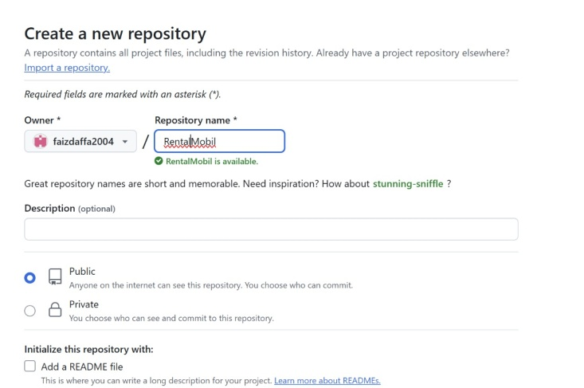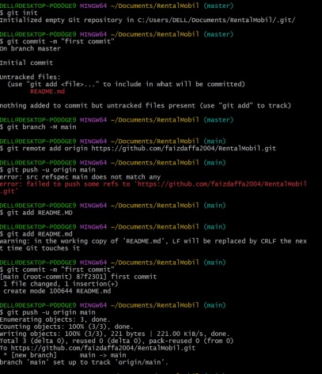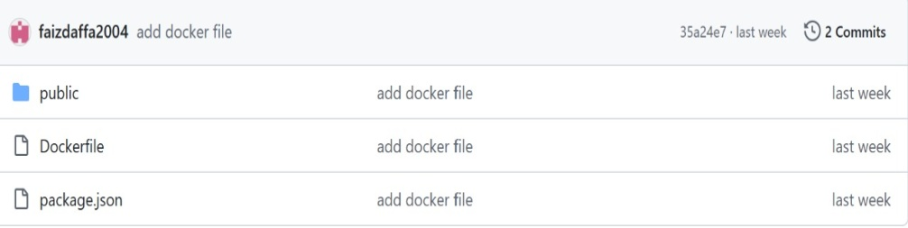

**DEVOPS IMPLEMENTATION**

1.4.

Add access to user 2 for the repo

user 1 merge from user1 which is tasyasyf/main.

**II.**

**U**

**SER**

**2**

**:**

2.1.

Git Clone Repository

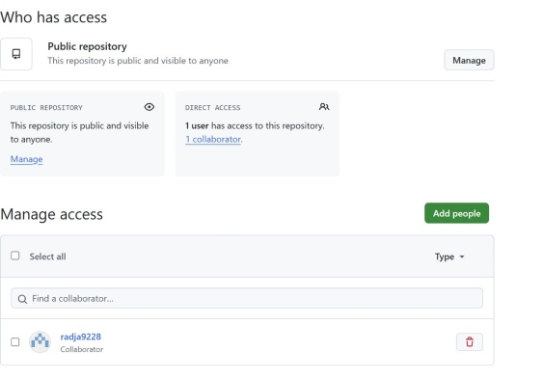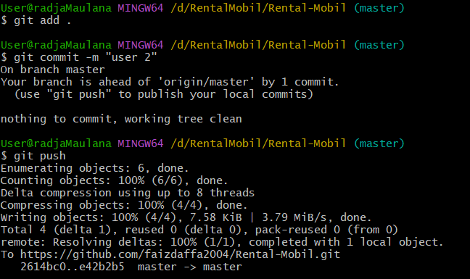

# DEVOPS IMPLEMENTATION

**III.**

**GITHUB,**

**JENKINS**

**, and Docker**

**1.**

**Github**

1.1.

Checking

Branch on the repo

1.2.

History

Commit

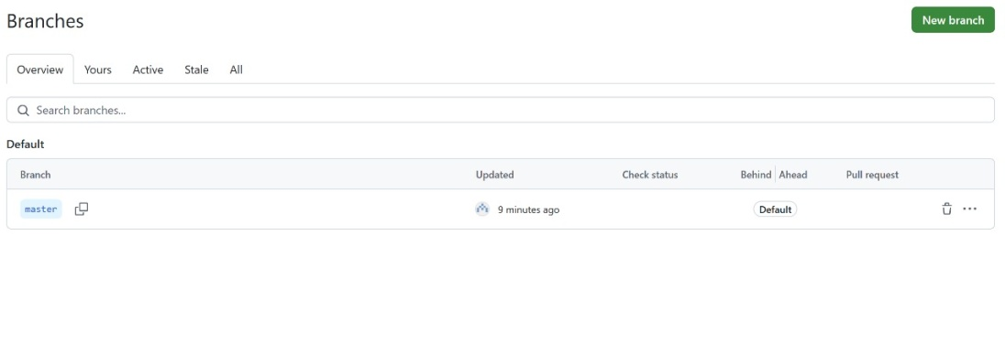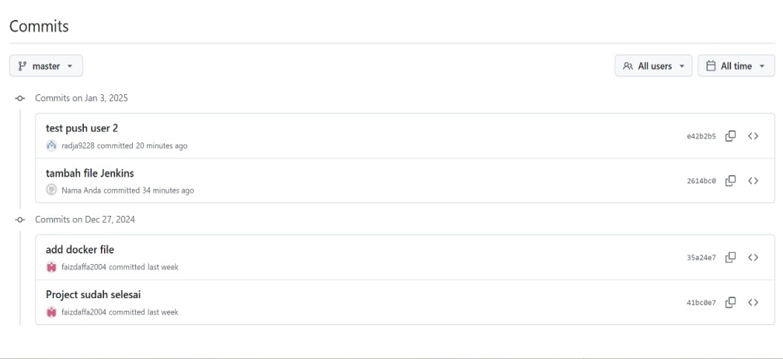

# DEVOPS IMPLEMENTATION

1.3.

Data contribute for our project

**2.**

**Jenkins**

**Freestyle**

2.1.

Create New Freestyle

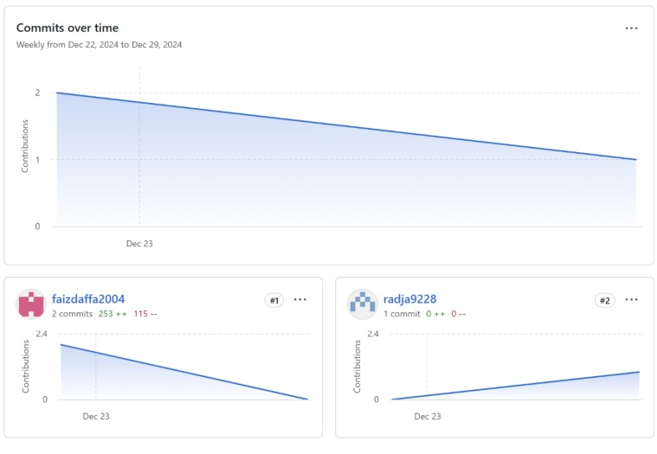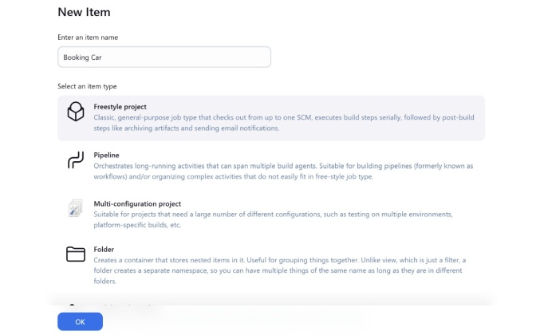

# DEVOPS IMPLEMENTATION

2.2.

Result Console Output

2.3.

Result of the item project

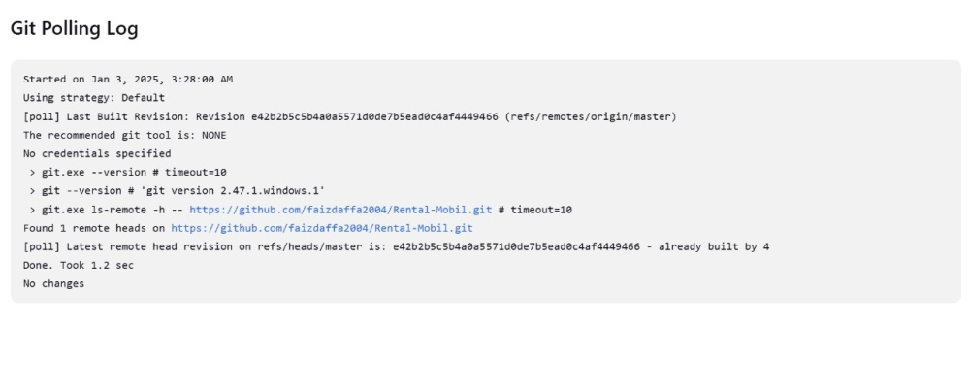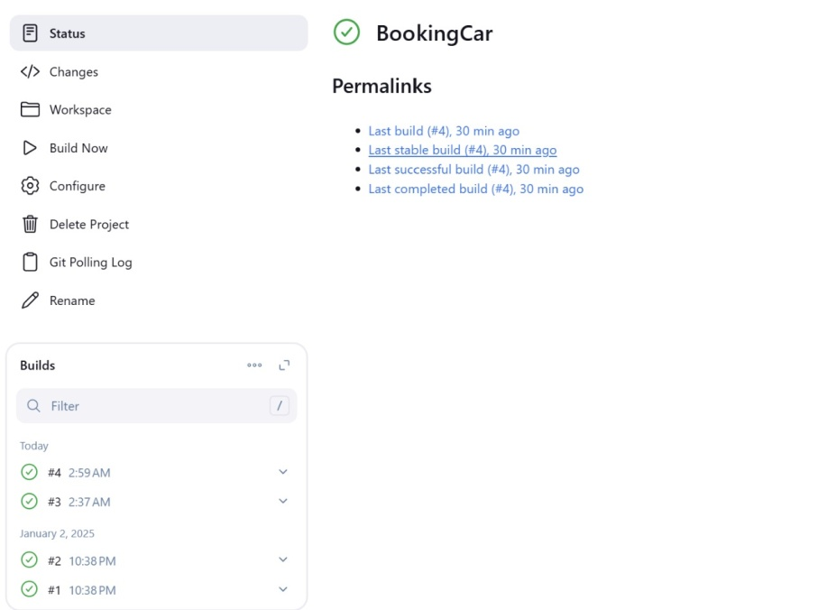

**DEVOPS IMPLEMENTATION**

**. Docker**

**3**

3.1.

Docker image

3.2.

Docker

containers

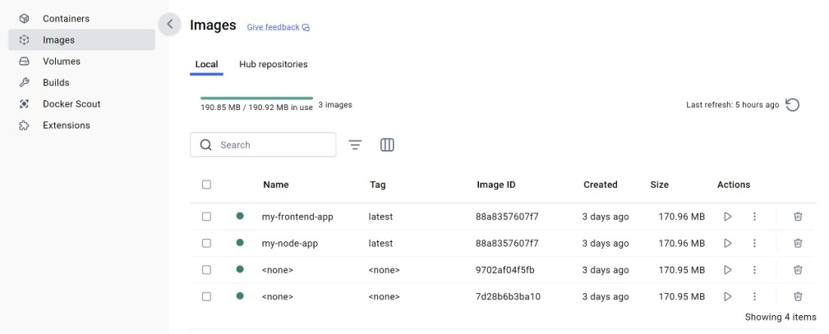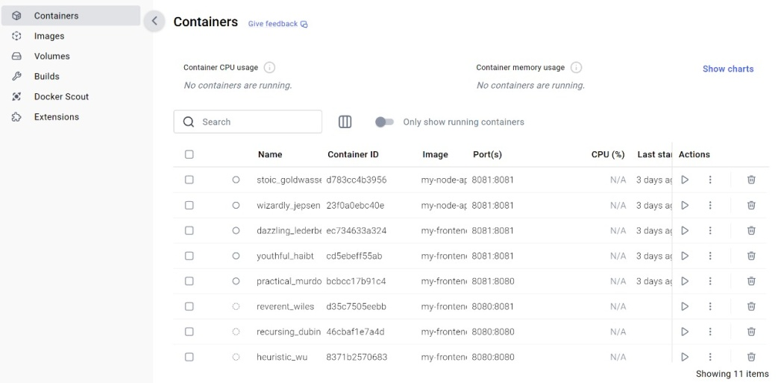

# DEVOPS IMPLEMENTATION

3.3.

Run

the localhost

in website

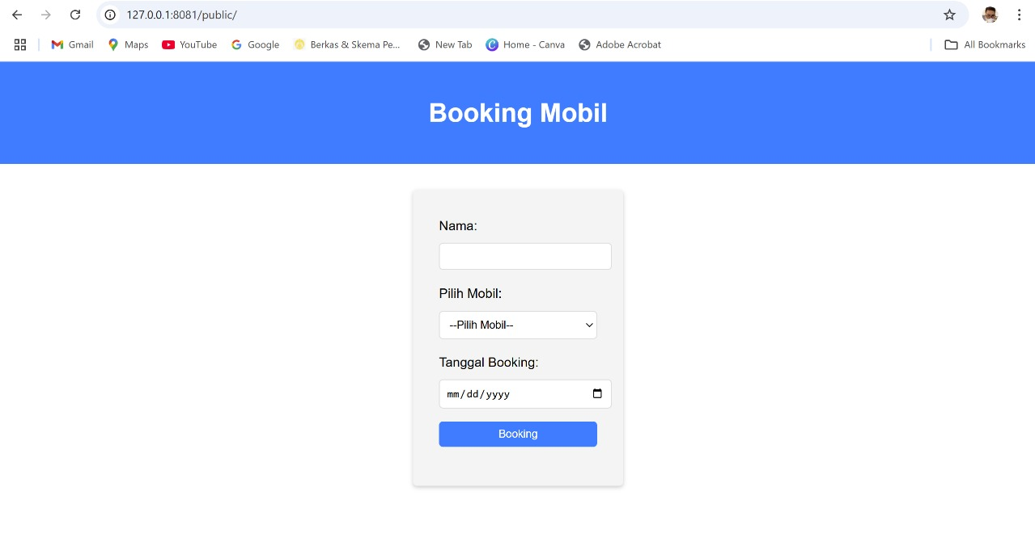

# ACTIVITY LIST

|  |  |  |  |  |  |  |  |  |  |  |  |  |  |  |  |  |  |  |  |  |  |  |  |  |  |  |  |  |  |  |  |  |  |  |  |  |  |  |  |  |  |  |  |  |  |  |  |  |  |  |  |  |  |  |  |  |  |  |  |  |
| --- | --- | --- | --- | --- | --- | --- | --- | --- | --- | --- | --- | --- | --- | --- | --- | --- | --- | --- | --- | --- | --- | --- | --- | --- | --- | --- | --- | --- | --- | --- | --- | --- | --- | --- | --- | --- | --- | --- | --- | --- | --- | --- | --- | --- | --- | --- | --- | --- | --- | --- | --- | --- | --- | --- | --- | --- | --- | --- | --- | --- |
| |  |  |  |  |  | | --- | --- | --- | --- | --- | | No | Activity | Start Date | End Date | Person(s) Involved | | 1 | Creating Repository | 22/1/2024 | 22/1/2024 | Faiz | | 2 | Push Project in Github | 22/12/2024 | 22/1/2024 | Faiz | | 3 | Forking Project | 22/12/2024 | 22/12/2024 | Faiz | | 4 | Cloning Website using Git | 22/12/2024 | 22/12/2024 | Faiz | | 5 | Change some code on website | 22/12/2024 | 22/12/2024 | Faiz & Radja | | 6 | Add and commit to local repository | 22/12/2024 | 22/12/2024 | Faiz & Radja | | 7 | Push Html to GitHub | 22/12/2024 | 23/1/2024 | Faiz & Radja | | 8 | Add pull request | 22/12/2024 | 23/1/2024 | Faiz | | 9 | Creating jenkins project | 28/12/2024 | 1/1/2025 | Faiz & Radja | | 10 | Build project in jenkins | 2/1/2024 | 2/1/2025 | Faiz & Radja | | 11 | Build Freestyle Project | 2/1/2024 | 2/1/2025 | Faiz & Radja |                               17 |

**CONFIGURATION**

|  |  |  |  |
| --- | --- | --- | --- |
| **Hardware :** Macbook M2  **Operating System :** MacOS  **Software :** Git, GitHub and Jenkins, Docker, Microsoft Word, Microsoft Power  Point | | | |
|  | **PROJECT FILE DETAILS** | | |
| **No** | **File Name** | **Remarks** |
| 1.    2.    3.  4.    5. | CV Website.rar    CV Website.docx    CV Website.pptx    https://github.com/andrinahaura/project1.git    <http://localhost:8081/> [o](http://localhost:8089/)n local Docker andrina haura’s laptop | Web folder contains Visual Studio syntax to create Booking Car website  The Paper of our project  Our Power Point presentation file    Our Github Repository    Our DockerHub |